**Date Submitted: 9/24**

**Task 00: Execute provided code**

**#include** <stdint.h>

**#include** <stdbool.h>

**#include** "inc/hw_memmap.h"

**#include** "inc/hw_types.h"

**#include** "driverlib/sysctl.h"

**#include** "driverlib/gpio.h"

uint8_t ui8PinData = 2;

**int** **main**(**void**)

{

// Task 00

**SysCtlClockSet**(SYSCTL_SYSDIV_5 | SYSCTL_USE_PLL | SYSCTL_XTAL_16MHZ | SYSCTL_OSC_MAIN);

**SysCtlPeripheralEnable**(SYSCTL_PERIPH_GPIOF);

**GPIOPinTypeGPIOOutput**(GPIO_PORTF_BASE, GPIO_PIN_1 | GPIO_PIN_2 | GPIO_PIN_3);

// T = 300 mS where LED stays on for 150 mS

**while**(1)

{

**GPIOPinWrite**(GPIO_PORTF_BASE, GPIO_PIN_1 | GPIO_PIN_2 | GPIO_PIN_3, ui8PinData);

**SysCtlDelay**(2000000);

**GPIOPinWrite**(GPIO_PORTF_BASE, GPIO_PIN_1 | GPIO_PIN_2 | GPIO_PIN_3, 0x00);

**SysCtlDelay**(2000000);

**if**(ui8PinData == 8)

ui8PinData = 2; // Reset the LED sequence

**else**

ui8PinData = ui8PinData * 2; // Increment the LED sequence

}

**return** 0;

}

**Youtube Link:**

**------------------------------------------------------------------------------------**

**Task 01:**

Youtube Link:

**Waveform of TASK 00:**

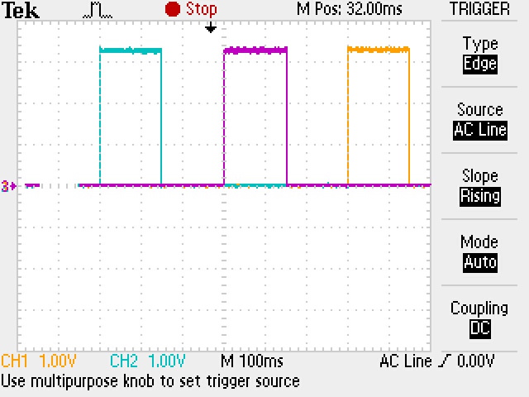

**The period of the provided code from TASK 00 is T = 300 mS. The LED turns on for 150 mS.**

**Modified Code:**

**#include** <stdint.h>

**#include** <stdbool.h>

**#include** "inc/hw_memmap.h"

**#include** "inc/hw_types.h"

**#include** "driverlib/sysctl.h"

**#include** "driverlib/gpio.h"

uint8_t ui8PinData = 2;

**int** **main**(**void**)

{

// Task 01

**SysCtlClockSet**(SYSCTL_SYSDIV_10 | SYSCTL_USE_PLL | SYSCTL_XTAL_16MHZ | SYSCTL_OSC_MAIN);

**SysCtlPeripheralEnable**(SYSCTL_PERIPH_GPIOF);

**GPIOPinTypeGPIOOutput**(GPIO_PORTF_BASE, GPIO_PIN_1 | GPIO_PIN_2 | GPIO_PIN_3);

// T = 1 s where LED stays on for 0.5 s

**while**(1)

{

**GPIOPinWrite**(GPIO_PORTF_BASE, GPIO_PIN_1 | GPIO_PIN_2 | GPIO_PIN_3, ui8PinData);

**SysCtlDelay**(3333333);

**GPIOPinWrite**(GPIO_PORTF_BASE, GPIO_PIN_1 | GPIO_PIN_2 | GPIO_PIN_3, 0x00);

**SysCtlDelay**(3333333);

**if**(ui8PinData == 8)

ui8PinData = 2; // Reset the LED sequence

**else**

ui8PinData = ui8PinData * 2; // Increment the LED sequence

}

**return** 0;

}

**Waveform of TASK 01:**

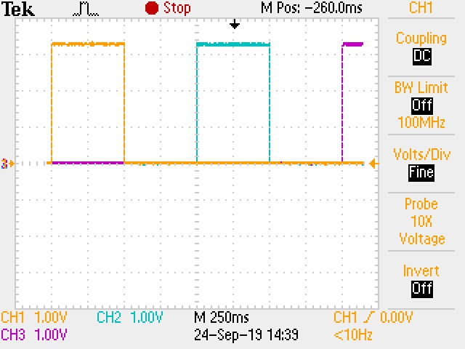

**Modifying the code from TASK 00 to show a wave with T = 1 s. The LED turns on for 500 mS.**

**------------------------------------------------------------------------------------**

**Task 02:**

Youtube Link:

**Modified Code:**

1. **Sequence the LED to blink BGR**

**#include** <stdint.h>

**#include** <stdbool.h>

**#include** "inc/hw_memmap.h"

**#include** "inc/hw_types.h"

**#include** "driverlib/sysctl.h"

**#include** "driverlib/gpio.h"

uint8_t ui8PinData = 2;

**int** **main**(**void**)

{

// Task 02

**SysCtlClockSet**(SYSCTL_SYSDIV_10 | SYSCTL_USE_PLL | SYSCTL_XTAL_16MHZ | SYSCTL_OSC_MAIN);

**SysCtlPeripheralEnable**(SYSCTL_PERIPH_GPIOF);

**GPIOPinTypeGPIOOutput**(GPIO_PORTF_BASE, GPIO_PIN_1 | GPIO_PIN_2 | GPIO_PIN_3);

// Color Values

// R = 2

// B = 4

// G = 8

// Task A - Blink the sequence BGR

**while**(1)

{

**GPIOPinWrite**(GPIO_PORTF_BASE, GPIO_PIN_1 | GPIO_PIN_2 | GPIO_PIN_3, ui8PinData);

**SysCtlDelay**(3333333);

**GPIOPinWrite**(GPIO_PORTF_BASE, GPIO_PIN_1 | GPIO_PIN_2 | GPIO_PIN_3, 0x00);

**SysCtlDelay**(3333333);

**if**(ui8PinData == 8)

ui8PinData = 2; // Reset the LED to RED

**else**

ui8PinData = ui8PinData * 2; // Increment the LED sequence

}

**return** 0;

}

1. **Sequence the LED to blink R, G, B, RG, RB, GB, RGB,…**

**#include** <stdint.h>

**#include** <stdbool.h>

**#include** "inc/hw_memmap.h"

**#include** "inc/hw_types.h"

**#include** "driverlib/sysctl.h"

**#include** "driverlib/gpio.h"

uint8_t ui8PinData = 1;

uint8_t seqCount = 1;

**int** **main**(**void**)

{

**while**(1)

{

**GPIOPinWrite**(GPIO_PORTF_BASE, GPIO_PIN_1 | GPIO_PIN_2 | GPIO_PIN_3, ui8PinData);

**SysCtlDelay**(2000000);

**GPIOPinWrite**(GPIO_PORTF_BASE, GPIO_PIN_1 | GPIO_PIN_2 | GPIO_PIN_3, 0x00);

**SysCtlDelay**(2000000);

**switch**(seqCount)

{

**case** 1:

**if**(ui8PinData == 0)

ui8PinData = 2; // Set to RED

**else**

{

ui8PinData = 0;

seqCount++;

}

**break**;

**case** 2:

**if**(ui8PinData == 0)

ui8PinData = 8; // Set to GREEN

**else**

{

ui8PinData = 0;

seqCount++;

}

**break**;

**case** 3:

**if**(ui8PinData == 0)

ui8PinData = 4; // Set to BLUE

**else**

{

ui8PinData = 0;

seqCount++;

}

**break**;

**case** 4:

**if**(ui8PinData == 0)

ui8PinData = 2; // Set to RED

**else** **if**(ui8PinData == 2)

ui8PinData = 8; // Set to GREEN

**else**

{

ui8PinData = 0;

seqCount++;

}

**break**;

**case** 5:

**if**(ui8PinData == 0)

ui8PinData = 2; // Set to RED

**else** **if**(ui8PinData == 2)

ui8PinData = 4; // Set to BLUE

**else**

{

ui8PinData = 0;

seqCount++;

}

**break**;

**case** 6:

**if**(ui8PinData == 0)

ui8PinData = 8; // Set to GREEN

**else** **if**(ui8PinData == 8)

ui8PinData = 4; // Set to BLUE

**else**

{

ui8PinData = 0;

seqCount++;

}

**break**;

**case** 7:

**if**(ui8PinData == 0)

ui8PinData = 2; // Set to RED

**else** **if**(ui8PinData == 2)

ui8PinData = 8; // Set to GREEN

**else** **if**(ui8PinData == 8)

ui8PinData = 4; // Set to BLUE

**else**

{

ui8PinData = 0;

seqCount = 1;

}

**break**;

**default**:

ui8PinData = 0; // Clear LED

seqCount = 1; // Reset sequence

}

}

**return** 0;

}